1.Construct a concept map showing the complete text processing pipeline in a Transformer.

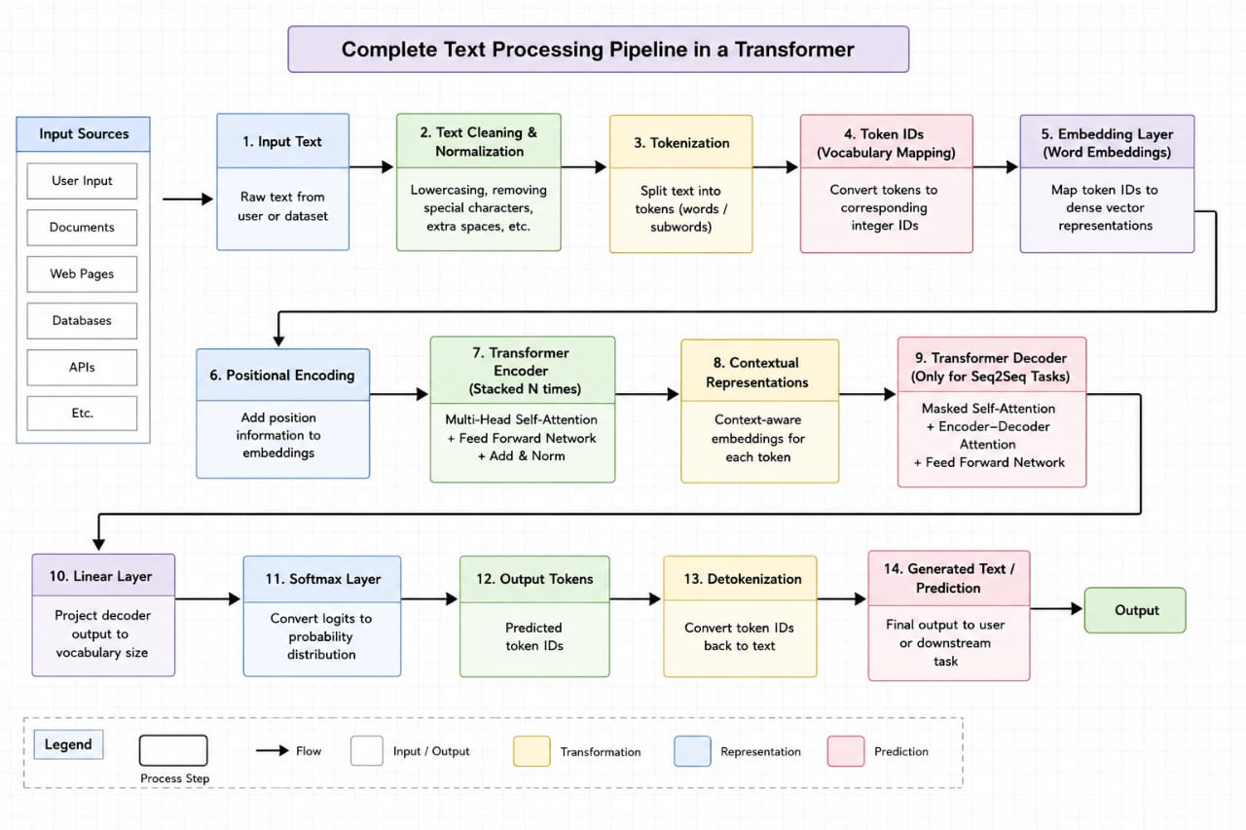

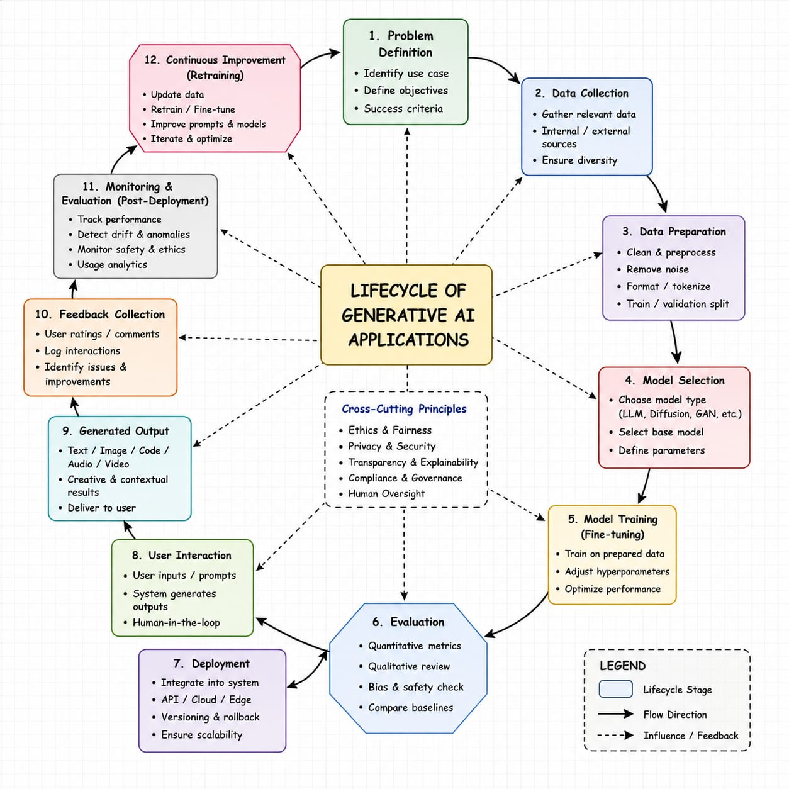
2. Construct a concept map illustrating the lifecycle of Generative AI applications.

